**SPRINT-2**

|  |  |
| --- | --- |
| TEAM ID | PNT2022TMID20252 |
| Project Name | IoT Based smart crop Protection system for agriculture |
| Maximum mark | 20 marks |

**STEP1: Download and Install NODE JS.**

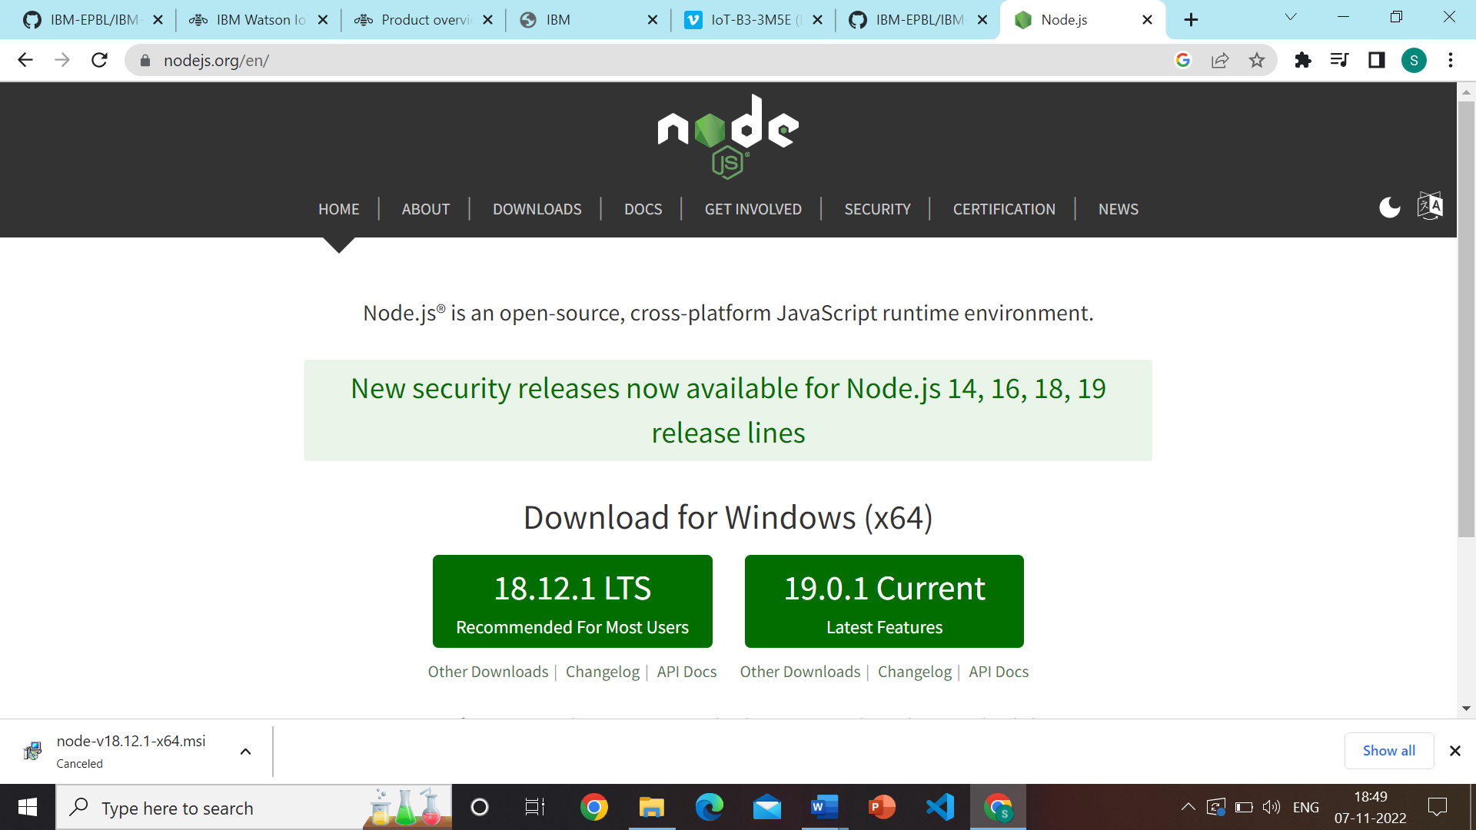

**STEP2: Setup node.js and configure command prompt for error check and open node-red from the generated link.**

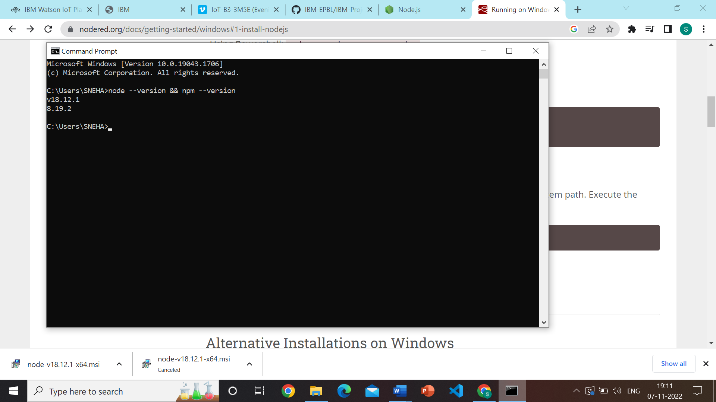

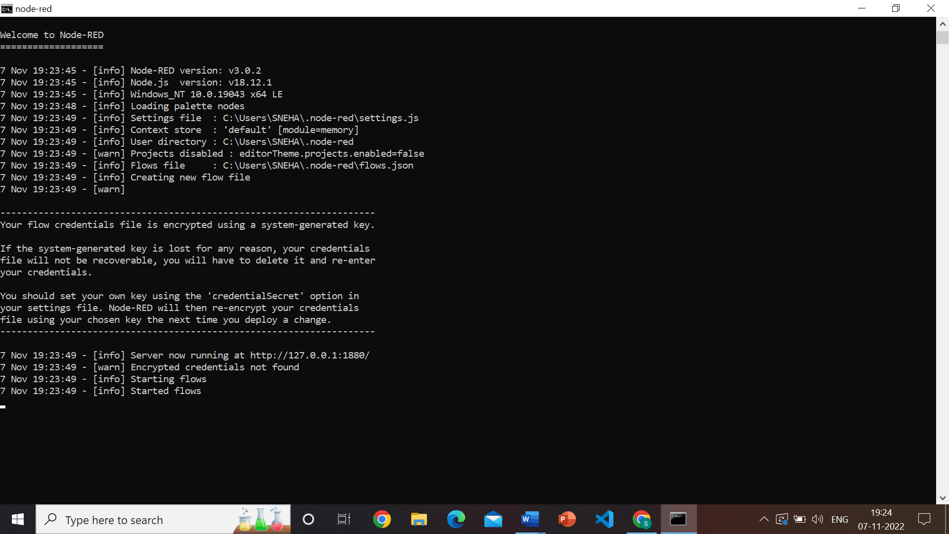

**STEP3: Connect Ibmiot in and Debug 1 and Deploy.**

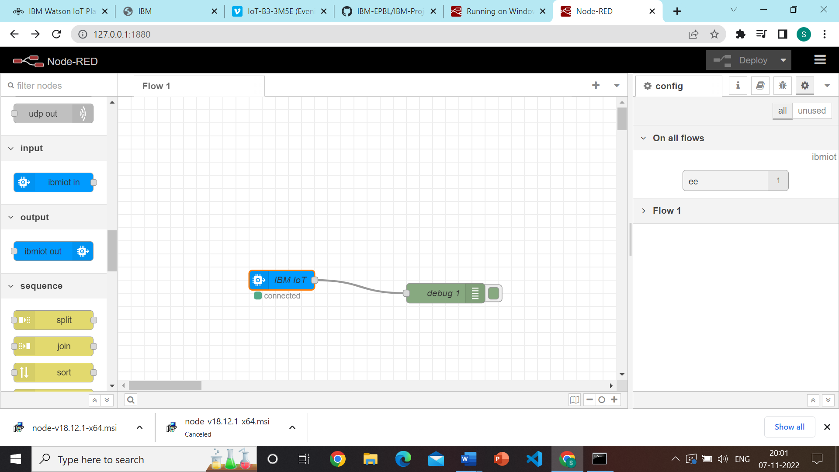

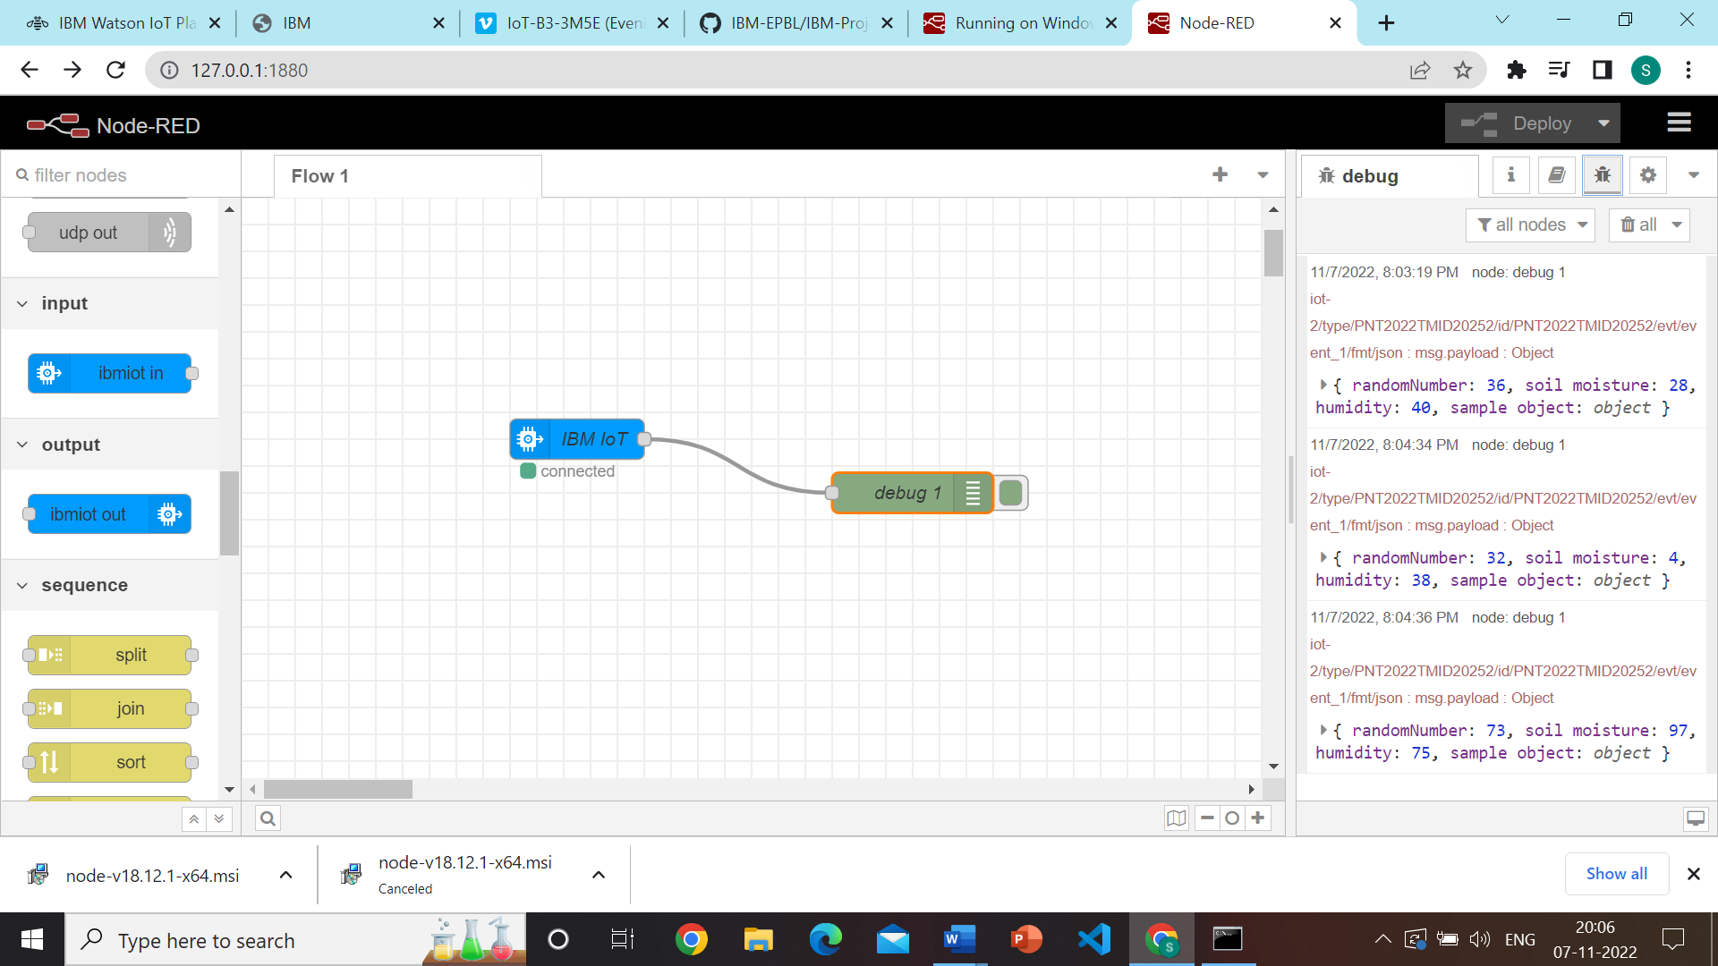

**STEP4: Edit gauge node (Here the gauge nodes are named as Temperature, Humidity and Soil moisture**

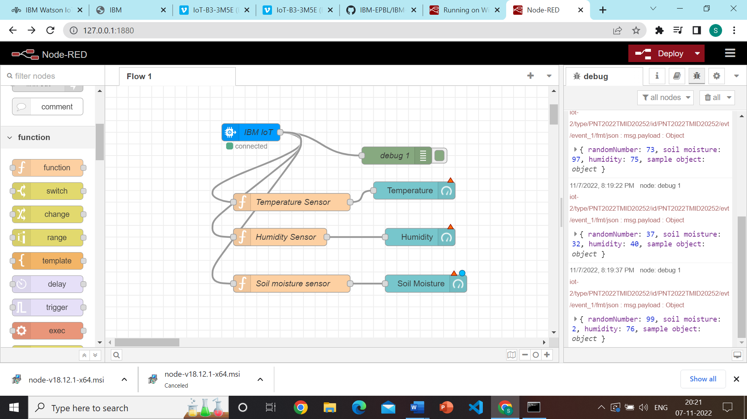

**STEP5: Simulated program to get the random values**

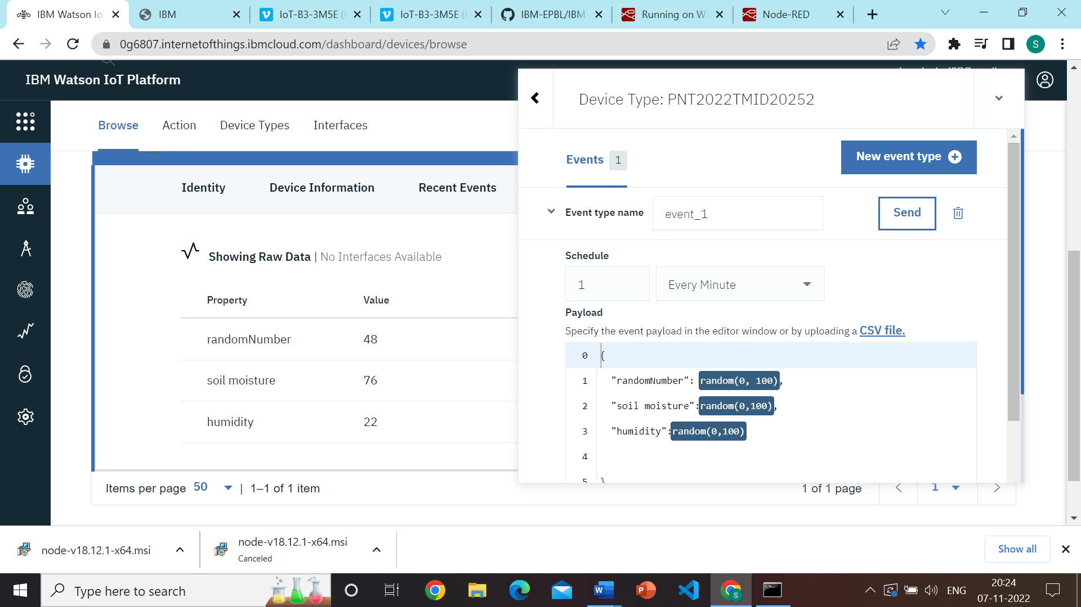

**STEP6: Generate debug message from IBM Watson IoT Platform and connect the nodes**



**STEP7: Generate the some output from recent events**

